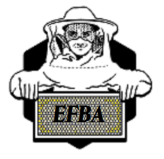
Elm Fork Beekeepers Association
Mission: To share information and provide education to our members and community about bees and beekeeping. To promote responsible beekeeping practices, through training and education, resulting in effective management of diseases, pests, and other environmental issues.

Board Meeting Agenda
Dec 03, 2020

- Officers reports
  - President - Jan Hodson
    - Welcome new board members
    - Bylaws
    - Google drive
  - Vice President – Michael Barber
    - Speakers
    - Scholarship
  - Secretary - Louann Barfknecht
    - Oct and Nov BM minutes
    - Nov GM minutes
  - Treasurer – Julie Haza
    - Reports/Membership
  - Communications – Susan Pritchard
  - Hospitality – Melanie Clinton
  - Education Coordinator – Byron Compton
    - Spring classes
    - Master Beekeeper Classes
    - Zoom meetings
  - Webmaster – Stacy Branam
  - Director at Large – Tim Branam
    - Survey for 2021

- Business
  - Pollen feeders (started with 30) 7 sold (23 left)
  - Vetch (200 lbs/40 5lbs bags) 2020 price: 5 lbs - $15, 10 lbs - $25 (16 left)
  - Xmas Party Dec 17^{th,}
    - Evite

Notes:

